PROJECT DOCUMENTATION

1. Introduction
This project is developed to analyze sales data and create an interactive dashboard for business decision-making. The objective is to transform raw sales data into meaningful insights regarding revenue trends, monthly trends, regional performance, product contribution, and salesperson effectiveness. The project was implemented using MySQL for data analysis and Power BI for data visualization.

2. Technology Stack
The following technologies were used during project development:
- Microsoft Excel – Data Source
- MySQL – Data Analysis and Querying
- Power BI – Dashboard Creation and Visualization
- GitHub – Project Repository and Version Control

3. Dataset Information
The dataset consists of sales transaction records containing the following attributes:
Field Name | Description
OrderDate | Transaction Date
Region | Sales Region
Manager | Manager Responsible for Sales
SalesMan | Sales Representative
Item | Product Name
Units | Number of Items Sold
Unit_price | Price Per Unit
Total Amount | Total Revenue Generated
The dataset was imported into MySQL and used for analytical processing.

4. Data Import Process

Step 1: Dataset Preparation
The dataset was reviewed to verify consistency and completeness.

Step 2: Dataset Imported into MySQL
The dataset was imported into MySQL using the Table Data Import Wizard.
Appropriate data types were assigned:
- OrderDate → Date
- Region → Text
- Manager → Text
- SalesMan → Text
- Item → Text
- Units → Int
- Unit_price → Double
- Total Amount → Double

Step 3: Validation
After importing, SQL queries were executed to verify successful data loading and data integrity.

5. SQL Analysis
Several SQL queries were executed to analyze business performance.

Best Selling Products
Used aggregation functions to determine products generating the highest revenue.
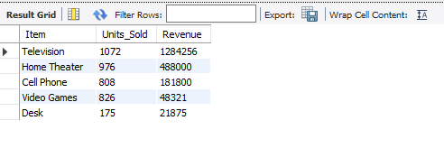

Region-wise Revenue Analysis
Grouped sales data by region to identify geographical performance.
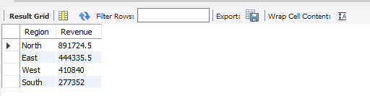

Top Salespersons Analysis
Evaluated salesperson performance based on revenue generation.
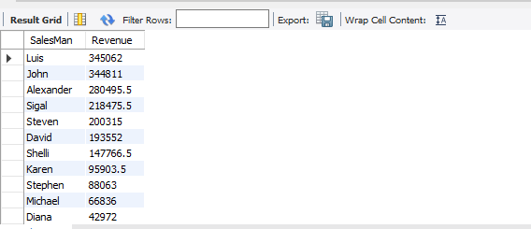

Manager Performance Analysis
Compared performance among managers.
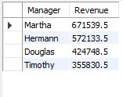

Monthly Revenue Trend Analysis
Analyzed sales patterns over time.
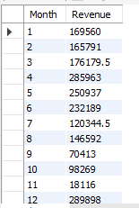

6. Power BI Dashboard Development
The dataset was imported into Power BI for visualization and dashboard creation.

Dashboard Page 1 – Sales Analytics Dashboard
Visuals:
- Total Revenue Card
- Total Units Sold Card
- Total Salespersons Card
- Total Products Card
- Monthly Revenue Trends (Line Chart)
- Region-wise Revenue Distribution (Donut Chart)
- Regions, Managers, Sales Man and Items (Slicer)
Purpose:
To provide a high-level overview of organizational sales performance.
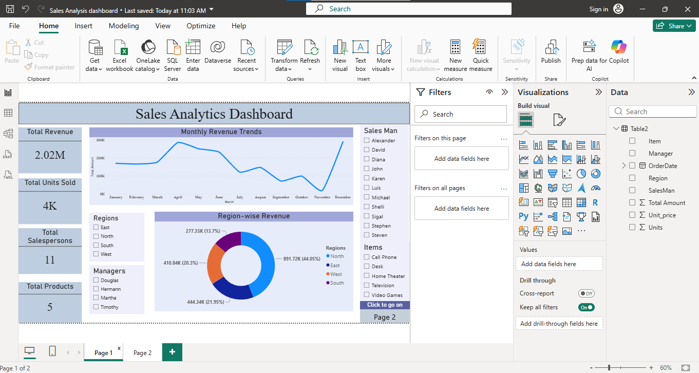

Dashboard Page 2 – Product & Sales Performance
Visuals:
- Manager Performance Analysis by Items (Clustered Column Chart)
- Units Sold by Each Sales person.
- Top Salespersons Analysis
- Product Contribution Treemap
- Key Business Insights
Purpose:
To provide detailed analysis of products and sales personnel.
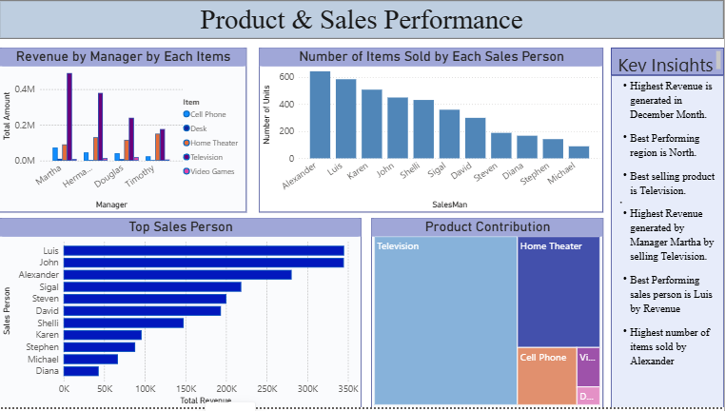

7. Dashboard Features
The dashboard provides the following functionality:
- Interactive filtering using slicers
- Dynamic data exploration
- Revenue trend monitoring
- Product performance analysis
- Regional sales analysis
- Salesperson performance evaluation
- Manager performance comparison

8. Key Metrics
The dashboard tracks the following key performance indicators:
- Total Revenue
- Total Units Sold
- Total Products
- Total Salespersons
These metrics provide a quick overview of overall business performance.

9. Project Deliverables
The final project includes:
- Power BI Dashboard (.pbix)
- SQL Query File (.sql)
- Dashboard Screenshots
- Project Report
- GitHub Repository

10. Conclusion
The project successfully demonstrates the use of SQL and Power BI for business intelligence and sales analytics. Through data analysis and visualization, meaningful insights were extracted from the dataset, enabling performance evaluation and supporting data-driven decision-making.

